**A Summer Internship report**

 On

**“PROGRAMMING LANGUAGES AND MACHINE LEARNING( Java , Python & Advanced Python)”**

Submitted in partial fulfillment of the requirement

for the award of the degree of

**Bachelor of Technology**

**in**

**Computer Science and Engineering**

**By**

PULLAGANTI REDDY SUDHAN REDDY

(21701A05E5)



**Department of Computer Science and Engineering**

**Annamacharya Institute of Technology and Sciences**

(An Autonomous Institution)

New Boyanapalli, Rajampet-516126 Kadapa (Dt), A.P.

Approved by AICTE, New-Delhi and affliated to J.N.T.U.A, Anantapuramu

Accredited by NBA & NAAC with A Grade

**2024-25**

**Department of Computer Science and Engineering**

**Annamacharya Institute of Technology and Sciences**

(An Autonomous Institution)

New Boyanapalli, Rajampet-516 126 Kadapa (Dt), A.P.

Approved by AICTE, New-Delhi and affliated to J.N.T.U.A, Anantapuramu

Accredited by NBA & NAAC with A Grade



**CERTIFICATE**

This is to certify that the summer Internship report entitled

**“PROGRAMMING LANGUAGES AND MACHINE LEARNING( Java , Python & Advanced Python)”** is submitted by

Name: **PULLAGANTI REDDY SUDHAN REDDY**

 Roll Number: **21701A05E5**

in partial fulfillment of the requirements for the award of Degree of **Bachelor of Technology** in **“Computer Science and Engineering”** for the academic year 2024-25.

**Summer Internship Supervisor                          Head of Department**

**Mr. C.V.Lakshmi Narayana                                Dr.M.SubbaRao**

Assistant Professor                                                 PROFISSOR and  HOD

Department of CSE                                                 Department of CSE

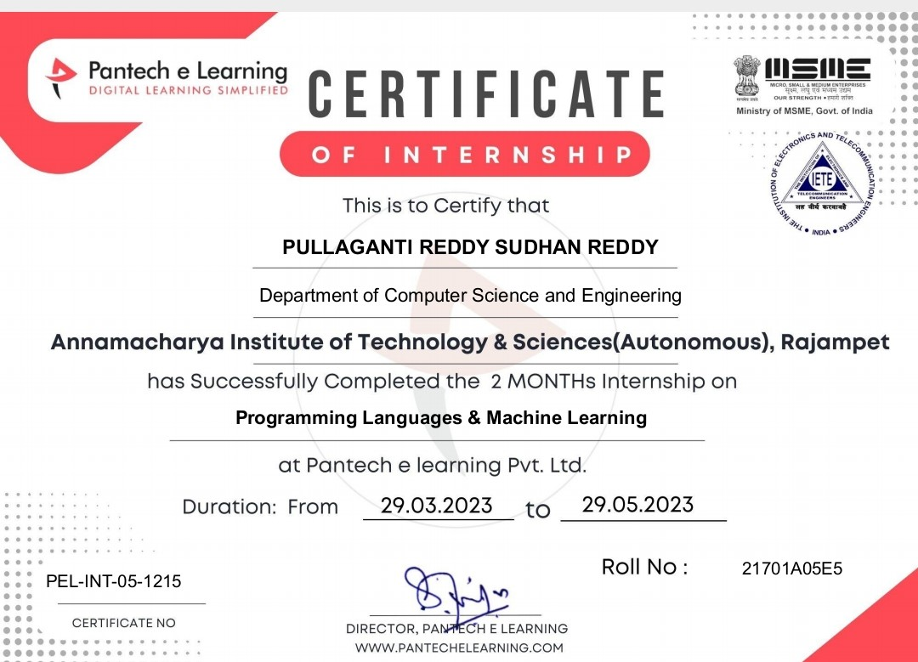

**CONTENTS**

* Programming language
* Types of programming language
* Most commonly used programming languages
* Python
* Java
* Advanced python
* What is machine learning?
* How does machine learning work
* History of machine learning
* Application of machine learning
* Machine learning life programming
* Difference between  Ml(machine learning) and AI(artificial intelligence)

Programming Language

As we know, to communicate with a person, we need a specific language, similarly to communicate with computers, programmers also need a language is called Programming language.

Before learning the programming language, let's understand what is language?

What is Language?

Language is a mode of communication that is used to **share ideas, opinions with each other**. For example, if we want to teach someone, we need a language that is understandable by both communicators.

What is a Programming Language?

A programming language is a **computer language** that is used by **programmers (developers) to communicate with computers**. It is a set of instructions written in any specific language ( C, C++, Java, Python) to perform a specific task.

A programming language is mainly used to **develop desktop applications, websites, and mobile applications**.

Types of programming language

**1. Low-level programming language**

Low-level language is **machine-dependent (0s and 1s)** programming language. The processor runs low- level programs directly without the need of a compiler or interpreter, so the programs written in low-level language can be run very fast.

Low-level language is further divided into two parts -

**i. Machine Language**

Machine language is a type of low-level programming language. It is also called as **machine code or object code**. Machine language is easier to read because it is normally displayed in binary or hexadecimal form (base 16) form. It does not require a translator to convert the programs because computers directly understand the machine language programs.

The advantage of machine language is that it helps the programmer to execute the programs faster than the high-level programming language.

**ii. Assembly Language**

Assembly language (ASM) is also a type of low-level programming language that is designed for specific processors. It represents the set of instructions in a **symbolic and human-understandable form**. It uses an assembler to convert the assembly language to machine language.

The advantage of assembly language is that it requires less memory and less execution time to execute a program.

**2. High-level programming language**

High-level programming language (HLL) is designed for **developing user-friendly software programs and websites**. This programming language requires a compiler or interpreter to translate the program into machine language (execute the program).

The main advantage of a high-level language is that it is **easy to read, write, and maintain**.

High-level programming language includes **Python, Java, JavaScript, PHP, C#, C++, Objective C, Cobol, Perl, Pascal, LISP, FORTRAN, and Swift programming language**.

A high-level language is further divided into three parts -

**i. Procedural Oriented programming language**

Procedural Oriented Programming (POP) language is derived from structured programming and based upon the procedure call concept. It divides a program into small procedures called **routines or functions**.

Procedural Oriented programming language is used by a software programmer to create a program that can be accomplished by using a programming editor like IDE, Adobe Dreamweaver, or Microsoft Visual Studio.

The advantage of POP language is that it helps programmers to easily track the program flow and code can be reused in different parts of the program.

***The advantage of POP language is that it helps programmers to easily track the program flow and code can be reused in different parts of the program.***

**Example:** C, FORTRAN, Basic, Pascal, etc.

**ii. Object-Oriented Programming language**

Object-Oriented Programming (OOP) language is **based upon the objects**. In this **programming language, programs are divided into small parts called objects**. It is used to implement real-world entities like inheritance, polymorphism, abstraction, etc in the program to makes the program resusable, efficient, and easy-to-use.

The main advantage of object-oriented programming is that OOP is faster and easier to execute, maintain, modify, as well as debug.

***Note: Object-Oriented Programming language follows a bottom-up approach.***

**Example:** C++, Java, Python, C#, etc.

**iii. Natural language**

Natural language is a **part of human languages** such as English, Russian, German, and Japanese. It is used by machines to understand, manipulate, and interpret human's language. It is used by developers to **perform tasks such as translation, automatic summarization, Named Entity Recognition (NER), relationship extraction, and topic segmentation**.

The main advantage of natural language is that it helps users to ask questions in any subject and directly respond within seconds.

**3. Middle-level programming language**

Middle-level programming language **lies between the low-level programming language and high-level programming language**. It is also known as the intermediate programming language and pseudo-language.

A middle-level programming language's advantages are that it supports the features of high-level programming, it is a user-friendly language, and closely related to machine language and human language.

**Example:** C, C++, language

Most commonly used Programming Language

As we all know, the programming language makes our life simpler. Currently, all sectors (like education, hospitals, banks, automobiles, and more ) completely depend upon the programming language.

There are dozens of programming languages used by the industries. Some most widely used programming languages are given below -

**1. Python**

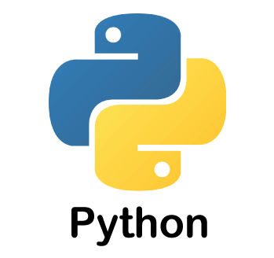

[Python](https://www.javatpoint.com/python-tutorial) is one of the most widely used user-friendly programming languages. It is an open-source and easy to learn programming language developed in the 1990s. It is **mostly used in**[**Machine learning**](https://www.javatpoint.com/machine-learning)**,**[**Artificial intelligence**](https://www.javatpoint.com/artificial-intelligence-tutorial)**, Big Data, GUI based desktop applications, and Robotics**.

**Advantages**

* Python is easy to read, easy to understand, and easy to write.
* It integrates with other programming languages like C, C++, and Java.
* Python executes code line-by-line, so it is easy for the programmer to find the error that occurred in the code.
* Python is platform-independent means you can write code once and run it anywhere.

**Disadvantages**

* Python is not suitable for developing mobile applications and games.
* Python works with the interpreter. That's why it is slower than other programming languages like C and C++.

**2. Java**

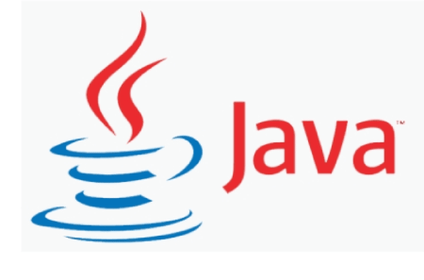

[Java](https://www.javatpoint.com/java-tutorial) is a simple, secure, platform-independent, reliable, architecture-neutral high-level programming language **developed by Sun Microsystems in 1995**. Now, Java is owned by Oracle. It is mainly used to develop bank, retail, information technology, android, big data, research community, web, and desktop applications.

**Advantages**

* Java is easy to write, compile, learn, and debug as compared to other programming languages.
* It provides an ability to run the same program on different platforms.
* It is a highly secured programming language because in java, there is no concept of explicit pointers.
* It is capable of performing multiple tasks at the same time.

**Disadvantages**

* Java consumes more memory and slower than other programming languages like C or C++.
* It does not provide a backup facility.

Advanced python:

Python is a high-level, object-oriented programming language that has recently been picked up by a lot of students as well as professionals due to its versatility, dynamic nature, robustness, and also because it is easy to learn. Not only this, it is now the second most loved and preferred language after JavaScript and can be used in almost all technical fields, be it machine learning, data science, web development, analytics, automation, testing, artificial intelligence, and a lot more.



Learning Python is easy as compared to other high-level, object-oriented programming languages such as Java or C++but it has a few advanced concepts that come in handy when developing code that is robust, crisp, highly optimized, efficient, and normalized. Using these concepts in your code, you will be able to reduce bugs in your code as well as increase its efficiency thereby making you a seasoned Python programmer. So let us look at these concepts one by one and understand them in detail!

1. Map Function

Python has an inbuilt function called *map()*which permits us to process all the elements present in an iterable without explicitly using a looping construct. When used, it returns a map object which in turn is an iterator. This [map](https://www.geeksforgeeks.org/python-map-function/)object is the result obtained by applying the specified function to every item present in the iterable.

***Function definition –****required\_answer = map(function, iterable)*

***The map() function takes two arguments:***

* The first argument is a function that is to be applied to each and every element present in the iterable.
* The second argument is the iterable itself on which the function is to be mapped.

2. itertools

Python has an amazing standard library called [itertools](https://www.geeksforgeeks.org/python-itertools/" \t "_blank)which provides a number of functions that help in writing clean, fast, and memory-efficient code due to lazy evaluation. It is a Python module that implements various iterator building blocks and together they form ‘iterator algebra’ which makes it possible to efficiently build tools in the Python language. The functions in itertools work on iterators themselves which in turn return more complex iterators. Some example of functions present in itertools are: count(), cycle(), repeat(), accumulate(), product(), permutations(), combinations() etc. each taking their own set of arguments and operating upon them. The result is generated a lot faster as compared to the results achieved when using conventional code.

3. Lambda Function

Python’s lambda functions are small anonymous functions as they do not have a name and are contained in a single line of code. The keyword ‘def’ is used to define functions in Python but [lambda](https://www.geeksforgeeks.org/python-lambda-anonymous-functions-filter-map-reduce/)functions are rather defined by the keyword ‘lambda’. They can take any number of arguments, but the number of expressions can only be one. It makes code concise and easy to read for simple logical operations and is best to use when you need to use the function only a single time.

***Function definition –****required\_answer = lambda ..arguments : expression*

4. Exception Handling

[Exceptions](https://www.geeksforgeeks.org/python-exception-handling/)are types of errors that occur when the program is being executed and change the normal flow of the program. An example could be dividing a number by zero or referencing an index that is outside the bounds of an iterable. Therefore, we use *try*, *except*,and *finally*to handle exceptions in Python. The keyword try is used to wrap a block of code that can potentially throw errors, *except*is used to wrap a block of code to be executed when an exception is raised and handles the error, and *finally*lets us execute the code no matter what.

5. Decorators

[Decorators](https://www.geeksforgeeks.org/decorators-in-python/)are a part of Python’s metaprogramming which are used to add additional functionality to existing code without altering the original structure at compile time. It is more like a regular function in Python that can be called and returns a callable. It takes in a function, modifies it by adding functionality, and then returns it. Want to start off in the field of Data Analytics & become a master in it? So get ready and learn the various aspects starting from the basics of Python with **[Geeksforgeeks Data Analysis with Python – Self-Paced course](https://practice.geeksforgeeks.org/courses/dsa-self-paced?utm_source=gfg-article&utm_medium=Q1-2023&utm_campaign=dsa-self-paced" \t "_blank)**specially curated by Sandeep Jain.

6. Collections

Collections in Python are general purpose inbuilt containers like sets, tuples, dictionaries, and lists. Python collections is a module that implements specialized container datatypes. [Collections](https://www.geeksforgeeks.org/python-collections-module/)include namedtuple() which is a function for creating tuple subclasses with named fields, OrderedDict which is a dict subclass that remembers the order entries that were added since Python dict isn’t ordered, Counter that is used for counting hashable objects, ChainMap that is used for creating a single view of multiple mappings, etc.

7. Generators

Generators in Python are a special type of function that rather than returning a single value, returns an iterator object which is a sequence of values. It is a utility to create your own iterator function. The keyword yield is used in the [*generator*](https://www.geeksforgeeks.org/generators-in-python/)function instead of the *return*keyword which pauses its execution. The difference between yield and return is that return terminates the function but yield only pauses the execution of the function and returns the value against it each time.

8. Magic Methods

Also called Dunder (or double underscore) methods, [magic methods](https://www.geeksforgeeks.org/dunder-magic-methods-python/" \t "_blank) are special types of functions that are invoked internally. They start and end with double underscores. Some examples include \_\_add\_\_(), \_\_abs\_\_(), \_\_round\_\_(), \_\_floor\_\_(), \_\_str\_\_(), \_\_trunc\_\_(), \_\_lshift\_\_() etc. The expression **number + 5** is the same as number.\_\_add\_\_(5) and this is internally called by other methods or actions. You can directly use these functions as it will decrease the run time of your code due to the fact that now due to direct use, we will be reducing a function call each time.

9. Threading

A Thread is the smallest unit or process that can be scheduled by an operating system. Python contains the [Thread](https://www.geeksforgeeks.org/multithreading-python-set-1/)class which aids in multithreaded programming. Multithreading is mainly used to speed up the computation to a huge extent as now more than one thread will be performing tasks. To implement threading in Python, you will need to use the *threading*module (since the *thread*module is deprecated).

10. Regular Expressions

Python regular expressions or [RegEx](https://www.geeksforgeeks.org/ruby-regular-expressions/" \t "_blank)are expressions that contain specific characters as patterns to be matched. It is used to check if a string or a set of strings contains a specific pattern. It is extremely powerful, elegant, and concise along with being fast. To use Python’s regular expressions, you need to import the *re*module which contains functions that help in pattern matching like findall(), search(), split(), etc.

These were the top advanced Python concepts that you must know to be an experienced Python developer. These will not only make you a good programmer and developer but will also improve code readability and make it faster.

Machine Learning Tutorial

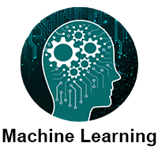

The Machine Learning Tutorial covers both the fundamentals and more complex ideas of machine learning. Students and professionals in the workforce can benefit from our machine learning tutorial.

A rapidly developing field of technology, machine learning allows computers to automatically learn from previous data. For building mathematical models and making predictions based on historical data or information, machine learning employs a variety of algorithms. It is currently being used for a variety of tasks, including speech recognition, email filtering, auto-tagging on Facebook, a recommender system, and image recognition.

You will learn about the many different methods of machine learning, including reinforcement learning, supervised learning, and unsupervised learning, in this machine learning tutorial. Regression and classification models, clustering techniques, hidden Markov models, and various sequential models will all be covered.

What is Machine Learning

In the real world, we are surrounded by humans who can learn everything from their experiences with their learning capability, and we have computers or machines which work on our instructions. But can a machine also learn from experiences or past data like a human does? So here comes the role of **Machine Learning**.

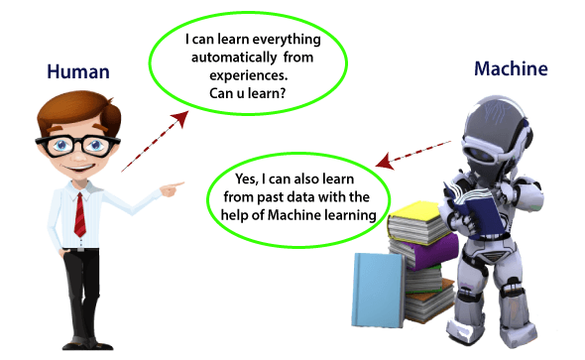

**Introduction to Machine Learning**

A subset of artificial intelligence known as machine learning focuses primarily on the creation of algorithms that enable a computer to independently learn from data and previous experiences. Arthur Samuel first used the term "machine learning" in 1959. It could be summarized as follows:

Without being explicitly programmed, machine learning enables a machine to automatically learn from data, improve performance from experiences, and predict things.

Machine learning algorithms create a mathematical model that, without being explicitly programmed, aids in making predictions or decisions with the assistance of sample historical data, or training data. For the purpose of developing predictive models, machine learning brings together statistics and computer science. Algorithms that learn from historical data are either constructed or utilized in machine learning. The performance will rise in proportion to the quantity of information we provide.

**A machine can learn if it can gain more data to improve its performance.**

How does Machine Learning work

A machine learning system builds prediction models, learns from previous data, and predicts the output of new data whenever it receives it. The amount of data helps to build a better model that accurately predicts the output, which in turn affects the accuracy of the predicted output.

Let's say we have a complex problem in which we need to make predictions. Instead of writing code, we just need to feed the data to generic algorithms, which build the logic based on the data and predict the output. Our perspective on the issue has changed as a result of machine learning. The Machine Learning algorithm's operation is depicted in the following block diagram:

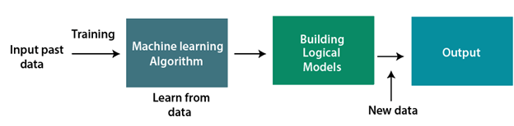

Features of Machine Learning:

* Machine learning uses data to detect various patterns in a given dataset.
* It can learn from past data and improve automatically.
* It is a data-driven technology.
* Machine learning is much similar to data mining as it also deals with the huge amount of the data.

Need for Machine Learning

The demand for machine learning is steadily rising. Because it is able to perform tasks that are too complex for a person to directly implement, machine learning is required. Humans are constrained by our inability to manually access vast amounts of data; as a result, we require computer systems, which is where machine learning comes in to simplify our lives.

By providing them with a large amount of data and allowing them to automatically explore the data, build models, and predict the required output, we can train machine learning algorithms. The cost function can be used to determine the amount of data and the machine learning algorithm's performance. We can save both time and money by using machine learning.

The significance of AI can be handily perceived by its utilization's cases, Presently, AI is utilized in self-driving vehicles, digital misrepresentation identification, face acknowledgment, and companion idea by Facebook, and so on. Different top organizations, for example, Netflix and Amazon have constructed AI models that are utilizing an immense measure of information to examine the client interest and suggest item likewise.

Following are some key points which show the importance of Machine Learning:

* Rapid increment in the production of data
* Solving complex problems, which are difficult for a human
* Decision making in various sector including finance
* Finding hidden patterns and extracting useful information from data.

Classification of Machine Learning

At a broad level, machine learning can be classified into three types:

1. **Supervised learning**
2. **Unsupervised learning**
3. **Reinforcement learning**

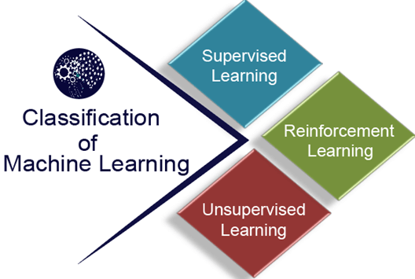

**1) Supervised Learning**

In supervised learning, sample labeled data are provided to the machine learning system for training, and the system then predicts the output based on the training data.

The system uses labeled data to build a model that understands the datasets and learns about each one. After the training and processing are done, we test the model with sample data to see if it can accurately predict the output.

The mapping of the input data to the output data is the objective of supervised learning. The managed learning depends on oversight, and it is equivalent to when an understudy learns things in the management of the educator. Spam filtering is an example of supervised learning.

Supervised learning can be grouped further in two categories of algorithms:

* **Classification**
* **Regression**

**2) Unsupervised Learning**

Unsupervised learning is a learning method in which a machine learns without any supervision.

The training is provided to the machine with the set of data that has not been labeled, classified, or categorized, and the algorithm needs to act on that data without any supervision. The goal of unsupervised learning is to restructure the input data into new features or a group of objects with similar patterns.

In unsupervised learning, we don't have a predetermined result. The machine tries to find useful insights from the huge amount of data. It can be further classifieds into two categories of algorithms:

* **Clustering**
* **Association**

**3) Reinforcement Learning**

Reinforcement learning is a feedback-based learning method, in which a learning agent gets a reward for each right action and gets a penalty for each wrong action. The agent learns automatically with these feedbacks and improves its performance. In reinforcement learning, the agent interacts with the environment and explores it. The goal of an agent is to get the most reward points, and hence, it improves its performance.

The robotic dog, which automatically learns the movement of his arms, is an example of Reinforcement learning.

*Note:****We will learn about the above types of machine learning in detail in later chapters.***

History of Machine Learning

Before some years (about 40-50 years), machine learning was science fiction, but today it is the part of our daily life. Machine learning is making our day to day life easy from **self-driving cars** to **Amazon virtual assistant "Alexa"**. However, the idea behind machine learning is so old and has a long history. Below some milestones are given which have occurred in the history of machine learning:

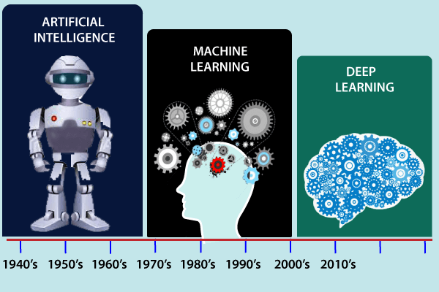

The early history of Machine Learning (Pre-1940):

* **1834:** In 1834, Charles Babbage, the father of the computer, conceived a device that could be programmed with punch cards. However, the machine was never built, but all modern computers rely on its logical structure.
* **1936:** In 1936, Alan Turing gave a theory that how a machine can determine and execute a set of instructions.

The era of stored program computers:

* **1940:** In 1940, the first manually operated computer, "ENIAC" was invented, which was the first electronic general-purpose computer. After that stored program computer such as EDSAC in 1949 and EDVAC in 1951 were invented.
* **1943:** In 1943, a human neural network was modeled with an electrical circuit. In 1950, the scientists started applying their idea to work and analyzed how human neurons might work.

Computer machinery and intelligence:

* **1950:** In 1950, Alan Turing published a seminal paper, "**Computer Machinery and Intelligence**," on the topic of artificial intelligence. **In his paper, he asked, "Can machines think?"**

Machine intelligence in Games:

* **1952:** Arthur Samuel, who was the pioneer of machine learning, created a program that helped an IBM computer to play a checkers game. It performed better more it played.
* **1959:** In 1959, the term "Machine Learning" was first coined by **Arthur Samuel**.

The first "AI" winter:

* The duration of 1974 to 1980 was the tough time for AI and ML researchers, and this duration was called as **AI winter**.
* In this duration, failure of machine translation occurred, and people had reduced their interest from AI, which led to reduced funding by the government to the researches.

Machine Learning from theory to reality

* **1959:** In 1959, the first neural network was applied to a real-world problem to remove echoes over phone lines using an adaptive filter.
* **1985:** In 1985, Terry Sejnowski and Charles Rosenberg invented a neural network **NETtalk**, which was able to teach itself how to correctly pronounce 20,000 words in one week.
* **1997:** The IBM's **Deep blue** intelligent computer won the chess game against the chess expert Garry Kasparov, and it became the first computer which had beaten a human chess expert.

Machine Learning at 21st century

**2006:**

* Geoffrey Hinton and his group presented the idea of profound getting the hang of utilizing profound conviction organizations.
* The Elastic Compute Cloud (EC2) was launched by Amazon to provide scalable computing resources that made it easier to create and implement machine learning models.

**2007:**

* Participants were tasked with increasing the accuracy of Netflix's recommendation algorithm when the Netflix Prize competition began.
* Support learning made critical progress when a group of specialists utilized it to prepare a PC to play backgammon at a top-notch level.

**2008:**

* Google delivered the Google Forecast Programming interface, a cloud-based help that permitted designers to integrate AI into their applications.
* Confined Boltzmann Machines (RBMs), a kind of generative brain organization, acquired consideration for their capacity to demonstrate complex information conveyances.

**2009:**

* Profound learning gained ground as analysts showed its viability in different errands, including discourse acknowledgment and picture grouping.
* The expression "Large Information" acquired ubiquity, featuring the difficulties and open doors related with taking care of huge datasets.

**2010:**

* The ImageNet Huge Scope Visual Acknowledgment Challenge (ILSVRC) was presented, driving progressions in PC vision, and prompting the advancement of profound convolutional brain organizations (CNNs).

**2011:**

* On Jeopardy! IBM's Watson defeated human champions., demonstrating the potential of question-answering systems and natural language processing.

**2012:**

* AlexNet, a profound CNN created by Alex Krizhevsky, won the ILSVRC, fundamentally further developing picture order precision and laying out profound advancing as a predominant methodology in PC vision.
* Google's Cerebrum project, drove by Andrew Ng and Jeff Dignitary, utilized profound figuring out how to prepare a brain organization to perceive felines from unlabeled YouTube recordings.

2013:

* Ian Goodfellow introduced generative adversarial networks (GANs), which made it possible to create realistic synthetic data.
* Google later acquired the startup DeepMind Technologies, which focused on deep learning and artificial intelligence.

**2014:**

* Facebook presented the DeepFace framework, which accomplished close human precision in facial acknowledgment.
* AlphaGo, a program created by DeepMind at Google, defeated a world champion Go player and demonstrated the potential of reinforcement learning in challenging games.

**2015:**

* Microsoft delivered the Mental Toolbox (previously known as CNTK), an open-source profound learning library.
* The performance of sequence-to-sequence models in tasks like machine translation was enhanced by the introduction of the idea of attention mechanisms.

**2016:**

* The goal of explainable AI, which focuses on making machine learning models easier to understand, received some attention.
* Google's DeepMind created AlphaGo Zero, which accomplished godlike Go abilities to play without human information, utilizing just support learning.

**2017:**

* Move learning acquired noticeable quality, permitting pretrained models to be utilized for different errands with restricted information.
* Better synthesis and generation of complex data were made possible by the introduction of generative models like variational autoencoders (VAEs) and Wasserstein GANs.
* These are only a portion of the eminent headways and achievements in AI during the predefined period. The field kept on advancing quickly past 2017, with new leap forwards, strategies, and applications arising.

Machine Learning at present:

The field of machine learning has made significant strides in recent years, and its applications are numerous, including self-driving cars, Amazon Alexa, Catboats, and the recommender system. It incorporates clustering, classification, decision tree, SVM algorithms, and reinforcement learning, as well as unsupervised and supervised learning.

Present day AI models can be utilized for making different expectations, including climate expectation, sickness forecast, financial exchange examination, and so on.

Prerequisites

Before learning machine learning, you must have the basic knowledge of followings so that you can easily understand the concepts of machine learning:

* Fundamental knowledge of probability and linear algebra.
* The ability to code in any computer language, especially in Python language.
* Knowledge of Calculus, especially derivatives of single variable and multivariate functions.

Applications of Machine learning

Machine learning is a buzzword for today's technology, and it is growing very rapidly day by day. We are using machine learning in our daily life even without knowing it such as Google Maps, Google assistant, Alexa, etc. Below are some most trending real-world applications of Machine Learning:

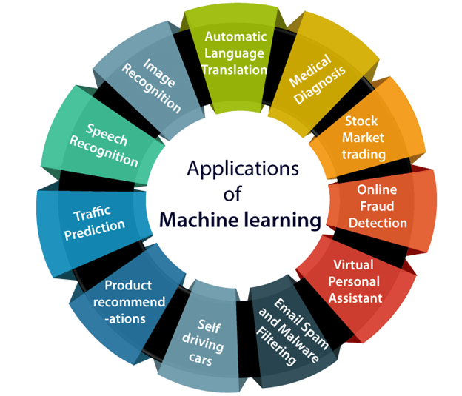

**1. Image Recognition:**

Image recognition is one of the most common applications of machine learning. It is used to identify objects, persons, places, digital images, etc. The popular use case of image recognition and face detection is, **Automatic friend tagging suggestion**:

Facebook provides us a feature of auto friend tagging suggestion. Whenever we upload a photo with our Facebook friends, then we automatically get a tagging suggestion with name, and the technology behind this is machine learning's **face detection** and **recognition algorithm**.

It is based on the Facebook project named "**Deep Face**," which is responsible for face recognition and person identification in the picture.

**2. Speech Recognition**

While using Google, we get an option of "**Search by voice**," it comes under speech recognition, and it's a popular application of machine learning.

Speech recognition is a process of converting voice instructions into text, and it is also known as "**Speech to text**", or "**Computer speech recognition**." At present, machine learning algorithms are widely used by various applications of speech recognition. **Google assistant**, **Siri**, **Cortana**, and **Alexa** are using speech recognition technology to follow the voice instructions.

**3. Traffic prediction:**

If we want to visit a new place, we take help of Google Maps, which shows us the correct path with the shortest route and predicts the traffic conditions.

It predicts the traffic conditions such as whether traffic is cleared, slow-moving, or heavily congested with the help of two ways:

* **Real Time location** of the vehicle form Google Map app and sensors
* **Average time has taken** on past days at the same time.

Everyone who is using Google Map is helping this app to make it better. It takes information from the user and sends back to its database to improve the performance.

**4. Product recommendations:**

Machine learning is widely used by various e-commerce and entertainment companies such as **Amazon**, **Netflix**, etc., for product recommendation to the user. Whenever we search for some product on Amazon, then we started getting an advertisement for the same product while internet surfing on the same browser and this is because of machine learning.

Google understands the user interest using various machine learning algorithms and suggests the product as per customer interest.

As similar, when we use Netflix, we find some recommendations for entertainment series, movies, etc., and this is also done with the help of machine learning.

**5. Self-driving cars:**

One of the most exciting applications of machine learning is self-driving cars. Machine learning plays a significant role in self-driving cars. Tesla, the most popular car manufacturing company is working on self-driving car. It is using unsupervised learning method to train the car models to detect people and objects while driving.

**6. Email Spam and Malware Filtering:**

Whenever we receive a new email, it is filtered automatically as important, normal, and spam. We always receive an important mail in our inbox with the important symbol and spam emails in our spam box, and the technology behind this is Machine learning. Below are some spam filters used by Gmail:

* Content Filter
* Header filter
* General blacklists filter
* Rules-based filters
* Permission filters

Some machine learning algorithms such as **Multi-Layer Perceptron**, **Decision tree**, and **Naïve Bayes classifier** are used for email spam filtering and malware detection.

**7. Virtual Personal Assistant:**

We have various virtual personal assistants such as **Google assistant**, **Alexa**, **Cortana**, **Siri**. As the name suggests, they help us in finding the information using our voice instruction. These assistants can help us in various ways just by our voice instructions such as Play music, call someone, Open an email, Scheduling an appointment, etc.

These virtual assistants use machine learning algorithms as an important part.

These assistant record our voice instructions, send it over the server on a cloud, and decode it using ML algorithms and act accordingly.

**8. Online Fraud Detection:**

Machine learning is making our online transaction safe and secure by detecting fraud transaction. Whenever we perform some online transaction, there may be various ways that a fraudulent transaction can take place such as **fake accounts**, **fake ids**, and **steal money** in the middle of a transaction. So to detect this, **Feed Forward Neural network** helps us by checking whether it is a genuine transaction or a fraud transaction.

For each genuine transaction, the output is converted into some hash values, and these values become the input for the next round. For each genuine transaction, there is a specific pattern which gets change for the fraud transaction hence, it detects it and makes our online transactions more secure.

**9. Stock Market trading:**

Machine learning is widely used in stock market trading. In the stock market, there is always a risk of up and downs in shares, so for this machine learning's **long short term memory neural network** is used for the prediction of stock market trends.

**10. Medical Diagnosis:**

In medical science, machine learning is used for diseases diagnoses. With this, medical technology is growing very fast and able to build 3D models that can predict the exact position of lesions in the brain.

It helps in finding brain tumors and other brain-related diseases easily.

**11. Automatic Language Translation:**

Nowadays, if we visit a new place and we are not aware of the language then it is not a problem at all, as for this also machine learning helps us by converting the text into our known languages. Google's GNMT (Google Neural Machine Translation) provide this feature, which is a Neural Machine Learning that translates the text into our familiar language, and it called as automatic translation.

The technology behind the automatic translation is a sequence to sequence learning algorithm, which is used with image recognition and translates the text from one language to another language.

Machine learning Life cycle

Machine learning has given the computer systems the abilities to automatically learn without being explicitly programmed. But how does a machine learning system work? So, it can be described using the life cycle of machine learning. Machine learning life cycle is a cyclic process to build an efficient machine learning project. The main purpose of the life cycle is to find a solution to the problem or project.

Machine learning life cycle involves seven major steps, which are given below:

* **Gathering Data**
* **Data preparation**
* **Data Wrangling**
* **Analyse Data**
* **Train the model**
* **Test the model**
* **Deployment**

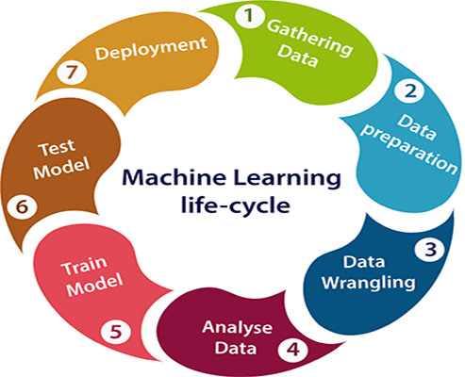

The most important thing in the complete process is to understand the problem and to know the purpose of the problem. Therefore, before starting the life cycle, we need to understand the problem because the good result depends on the better understanding of the problem.

In the complete life cycle process, to solve a problem, we create a machine learning system called "model", and this model is created by providing "training". But to train a model, we need data, hence, life cycle starts by collecting data.

Shape

1. Gathering Data:

Data Gathering is the first step of the machine learning life cycle. The goal of this step is to identify and obtain all data-related problems.

In this step, we need to identify the different data sources, as data can be collected from various sources such as **files**, **database**, **internet**, or **mobile devices**. It is one of the most important steps of the life cycle. The quantity and quality of the collected data will determine the efficiency of the output. The more will be the data, the more accurate will be the prediction.

This step includes the below tasks:

* **Identify various data sources**
* **Collect data**
* **Integrate the data obtained from different sources**

By performing the above task, we get a coherent set of data, also called as a **dataset**. It will be used in further steps.

Shape

2. Data preparation

After collecting the data, we need to prepare it for further steps. Data preparation is a step where we put our data into a suitable place and prepare it to use in our machine learning training.

In this step, first, we put all data together, and then randomize the ordering of data.

This step can be further divided into two processes:

* **Data exploration:**   
  It is used to understand the nature of data that we have to work with. We need to understand the characteristics, format, and quality of data.   
  A better understanding of data leads to an effective outcome. In this, we find Correlations, general trends, and outliers.
* **Data pre-processing:**   
  Now the next step is preprocessing of data for its analysis.

Shape

3. Data Wrangling

Data wrangling is the process of cleaning and converting raw data into a useable format. It is the process of cleaning the data, selecting the variable to use, and transforming the data in a proper format to make it more suitable for analysis in the next step. It is one of the most important steps of the complete process. Cleaning of data is required to address the quality issues.

It is not necessary that data we have collected is always of our use as some of the data may not be useful. In real-world applications, collected data may have various issues, including:

* **Missing Values**
* **Duplicate data**
* **Invalid data**
* **Noise**

So, we use various filtering techniques to clean the data.

It is mandatory to detect and remove the above issues because it can negatively affect the quality of the outcome.

Shape

4. Data Analysis

Now the cleaned and prepared data is passed on to the analysis step. This step involves:

* **Selection of analytical techniques**
* **Building models**
* **Review the result**

The aim of this step is to build a machine learning model to analyze the data using various analytical techniques and review the outcome. It starts with the determination of the type of the problems, where we select the machine learning techniques such as **Classification**, **Regression**, **Cluster analysis**, **Association**, etc. then build the model using prepared data, and evaluate the model.

Hence, in this step, we take the data and use machine learning algorithms to build the model.

Shape

5. Train Model

Now the next step is to train the model, in this step we train our model to improve its performance for better outcome of the problem.

We use datasets to train the model using various machine learning algorithms. Training a model is required so that it can understand the various patterns, rules, and, features.

Shape

6. Test Model

Once our machine learning model has been trained on a given dataset, then we test the model. In this step, we check for the accuracy of our model by providing a test dataset to it.

Testing the model determines the percentage accuracy of the model as per the requirement of project or problem.



7. Deployment

The last step of machine learning life cycle is deployment, where we deploy the model in the real-world system.

If the above-prepared model is producing an accurate result as per our requirement with acceptable speed, then we deploy the model in the real system. But before deploying the project, we will check whether it is improving its performance using available data or not. The deployment phase is similar to making the final report for a project.

Difference between Artificial intelligence and Machine learning

Artificial intelligence and machine learning are the part of computer science that are correlated with each other. These two technologies are the most trending technologies which are used for creating intelligent systems.

Although these are two related technologies and sometimes people use them as a synonym for each other, but still both are the two different terms in various cases.

On a broad level, we can differentiate both AI and ML as:

*AI is a bigger concept to create intelligent machines that can simulate human thinking capability and behavior, whereas, machine learning is an application or subset of AI that allows machines to learn from data without being programmed explicitly.*



Below are some main differences between AI and machine learning along with the overview of Artificial intelligence and machine learning.



Artificial Intelligence

Artificial intelligence is a field of computer science which makes a computer system that can mimic human intelligence. It is comprised of two words "**Artificial**" and "**intelligence**", which means "a human-made thinking power." Hence we can define it as,

*Artificial intelligence is a technology using which we can create intelligent systems that can simulate human intelligence.*

The Artificial intelligence system does not require to be pre-programmed, instead of that, they use such algorithms which can work with their own intelligence. It involves machine learning algorithms such as Reinforcement learning algorithm and deep learning neural networks. AI is being used in multiple places such as Siri, Google?s AlphaGo, AI in Chess playing, etc.

Based on capabilities, AI can be classified into three types:

* **Weak AI**
* **General AI**
* **Strong AI**

Currently, we are working with weak AI and general AI. The future of AI is Strong AI for which it is said that it will be intelligent than humans.



Machine learning

Machine learning is about extracting knowledge from the data. It can be defined as,

*Machine learning is a subfield of artificial intelligence, which enables machines to learn from past data or experiences without being explicitly programmed.*

Machine learning enables a computer system to make predictions or take some decisions using historical data without being explicitly programmed. Machine learning uses a massive amount of structured and semi-structured data so that a machine learning model can generate accurate result or give predictions based on that data.

Machine learning works on algorithm which learn by it?s own using historical data. It works only for specific domains such as if we are creating a machine learning model to detect pictures of dogs, it will only give result for dog images, but if we provide a new data like cat image then it will become unresponsive. Machine learning is being used in various places such as for online recommender system, for Google search algorithms, Email spam filter, Facebook Auto friend tagging suggestion, etc.

It can be divided into three types:

* **Supervised learning**
* **Reinforcement learning**
* **Unsupervised learning**



Key differences between Artificial Intelligence (AI) and Machine learning (ML):

|  |  |
| --- | --- |
| **Artificial Intelligence** | **Machine learning** |
| Artificial intelligence is a technology which enables a machine to simulate human behavior. | Machine learning is a subset of AI which allows a machine to automatically learn from past data without programming explicitly. |
| The goal of AI is to make a smart computer system like humans to solve complex problems. | The goal of ML is to allow machines to learn from data so that they can give accurate output. |
| In AI, we make intelligent systems to perform any task like a human. | In ML, we teach machines with data to perform a particular task and give an accurate result. |
| Machine learning and deep learning are the two main subsets of AI. | Deep learning is a main subset of machine learning. |
| AI has a very wide range of scope. | Machine learning has a limited scope. |
| AI is working to create an intelligent system which can perform various complex tasks. | Machine learning is working to create machines that can perform only those specific tasks for which they are trained. |
| AI system is concerned about maximizing the chances of success. | Machine learning is mainly concerned about accuracy and patterns. |
| The main applications of AI are **Siri, customer support using catboats**, Expert System, Online game playing, intelligent humanoid robot, etc. | The main applications of machine learning are **Online recommender system**, **Google search algorithms**, **Facebook auto friend tagging suggestions**, etc. |
| On the basis of capabilities, AI can be divided into three types, which are, **Weak AI**, **General AI**, and **Strong AI**. | Machine learning can also be divided into mainly three types that are **Supervised learning**, **Unsupervised learning**, and **Reinforcement learning**. |
| It includes learning, reasoning, and self-correction. | It includes learning and self-correction when introduced with new data. |
| AI completely deals with Structured, semi-structured, and unstructured data. | Machine learning deals with Structured and semi-structured data. |

**CONCLUSION:**

"**In conclusion, my internship experience in [specific programming language] and machine learning has been immensely rewarding and educational. Throughout the internship, I had the opportunity to apply theoretical concepts to real-world projects, enhancing my proficiency in [programming language] and gaining valuable insights into the intricate world of machine learning. The hands-on experience not only strengthened my technical skills but also fostered a deep appreciation for the collaborative and innovative nature of the field.**

**I am grateful for the guidance and mentorship I received during this internship, which has not only expanded my technical expertise but also provided me with a broader perspective on the industry. The exposure to cutting-edge technologies and collaborative projects has fueled my passion for [programming language] and machine learning.**

**As I reflect on this experience, I am confident that the skills and knowledge gained will serve as a solid foundation for my future endeavors. I look forward to leveraging these insights in my academic and professional journey, contributing to the ever-evolving landscape of programming and machine learning.**

**I extend my sincere appreciation to [mention names of mentors or colleagues], without whom this enriching experience would not have been possible. This internship has not only equipped me with technical skills but has also instilled in me a commitment to continuous learning and a passion for pushing the boundaries of what is possible in the exciting realm of programming and machine learning."**

**Feel free to tailor this conclusion to your specific experiences and key learnings during your internship.**

**REFERENCES**

**Books on  programming languages and machine learning:**

**Book: "Python Crash Course" by Eric Matthes**

**Online Course: "Python for Data Science and Machine Learning Bootcamp" on Udemy**

**Documentation:** [**Python Official Documentation**](https://docs.python.org/3/)

**Book: "Effective Java" by Joshua Bloch**

**Online Course: "Java Programming and Software Engineering Fundamentals" on Coursera**

**Documentation:** [**Java Official Documentation**](https://docs.oracle.com/en/java/)

**Kaggle:**

**.Participate in Kaggle competitions and explore datasets to apply your machine learning skills in a practical setting.**

**W3Schools:**

* [**W3Schools Python Tutorial**](https://www.w3schools.com/python/)

**Codecademy:**

* [**Codecademy Python Course**](https://www.codecademy.com/learn/learn-python-3)
* **Codecademy offers interactive coding lessons, including Python courses.**

**GitHub:**

* [**GitHub**](https://github.com/)
* **Explore open-source machine learning projects on GitHub to understand real-world applications and coding practices.**